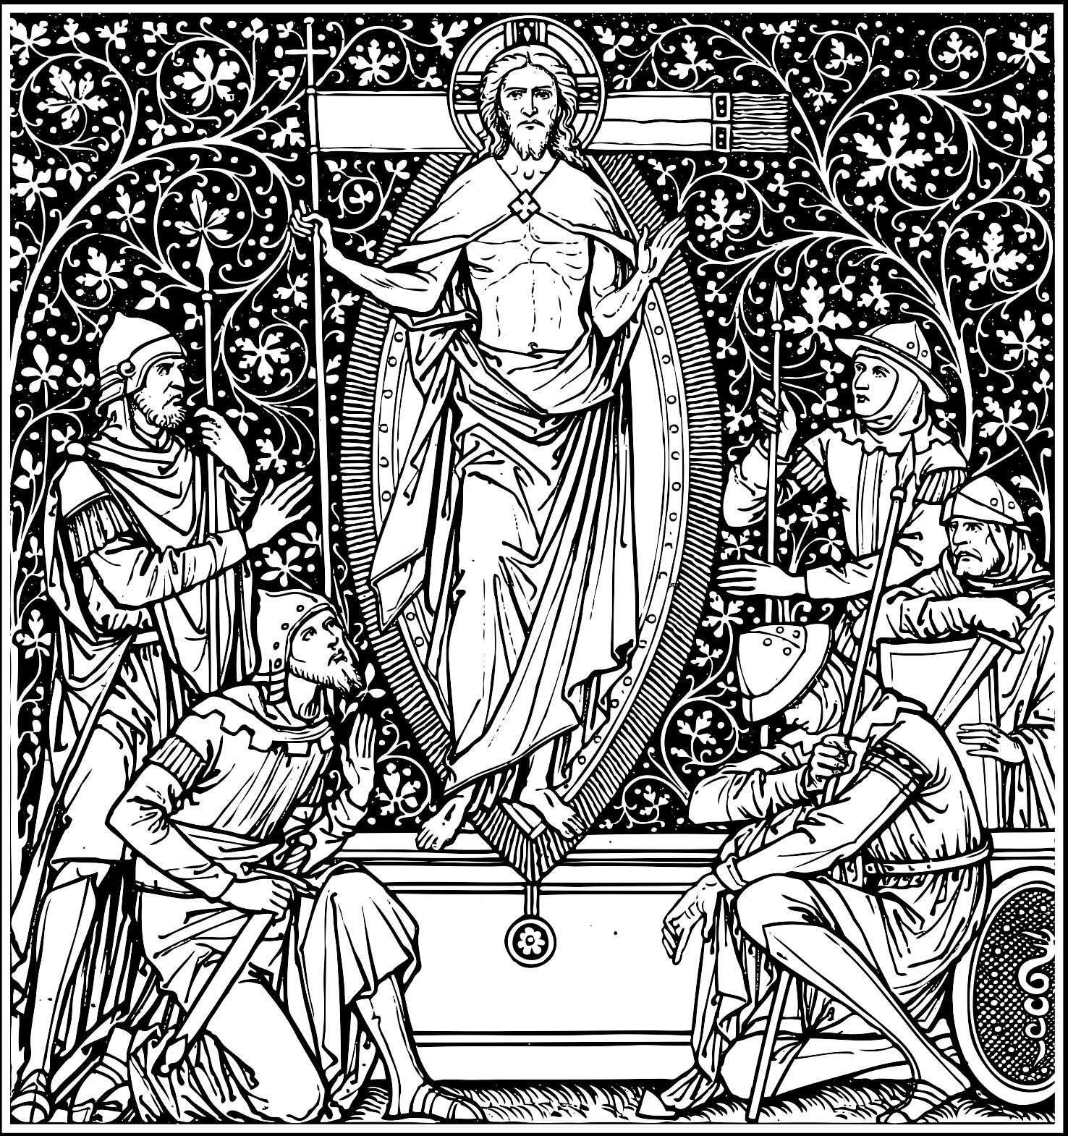
BRIGHT WITH A GLORIOUS SPLENDOR, FOR
ST. JOHN’S EPISCOPAL CHURCH A.D. 2024
✢
✢
✢
REJOICE AND SING NOW, ALL THE ROUND EARTH,
DARKNESS HAS BEEN VANQUISHED BY OUR ETERNAL KING.
✢

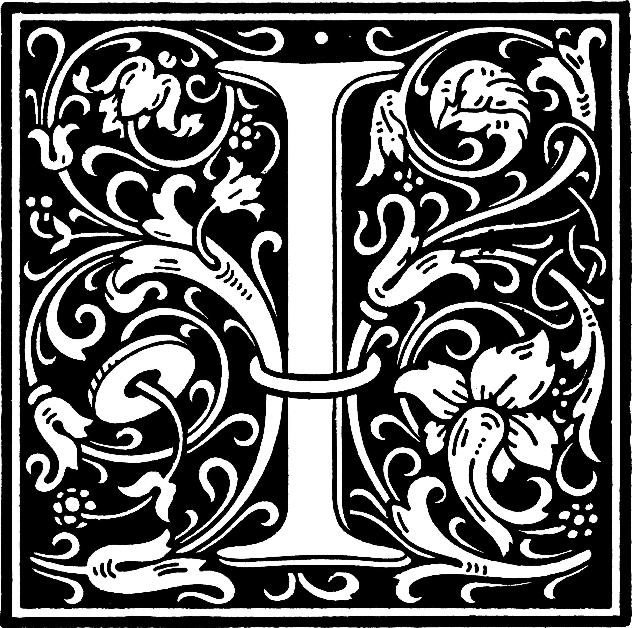
n the earliest days of the Church, it was the custom of the first Christian believers to gather under the cover of darkness—in homes, caves, and catacombs—to keep vigil together as they awaited the dawn of Easter.
In their ancient liturgy, these forebears of our faith lit the new Easter fire; recounted the stories of God’s saving deeds; baptized converts to the faith; and celebrated the first Eucharist of Easter.
Tonight, we join them in this centuries-old tradition, and we as a congregation once again become the pilgrim people of God. This is the Great Vigil of Easter: the brightest jewel of all Christian liturgy, the climax of the Christian year, the queen of feasts and seasons, and the crown of all our earthly worship.
Candle Safety: Please exercise caution with your candle. While it is traditional to keep vigil candles lit through the Old Testament stories and baptisms, you may extinguish your candle any time prior.
Children’s Chapel: All children PreK through third grade are invited to follow volunteers to Children’s Chapel immediately after the baptisms.
Communion: All baptized Christians may receive Communion at St. John’s. If you are curious about how Communion will work, see instructions on page 29.
If you are new to St. John’s, we want you to know you are especially welcome, and we hope you will make yourself at home. This worship booklet contains the full service for your convenience. Thank you for joining us for the most important service of the Christian year.
Please silence your cell phone before worship.

The Lighting of the Paschal Candle
All stand as the procession enters in silence.
In the darkness, fire is kindled; after which the Celebrant addresses the people in these words
Dear friends in Christ: On this most holy night, in which our Lord Jesus Christ passed over from death to life, the Church invites her members, dispersed throughout the world, to gather in vigil and prayer, for this is the Passover of the Lord. Here we join our voices with those of faithful Christians across the span of ages. With our mothers and fathers, our sisters and brothers, the holy forebears of our ancient faith, we gather in darkness to light the new Paschal fire, to recount God’s saving deeds, to pass through the waters of baptism, and to share with all creation in the triumph of our mighty King. This is the Great Vigil of Easter.
Let us pray.
Eternal God, ruler of the ages, through your only-begotten Son you have bestowed upon your people the brightness of your eternal light: Sanctify this new fire, and grant that in this Paschal feast we may so burn with heavenly desires, that with pure minds we may attain to the festival of everlasting light; through Jesus Christ our Lord. Amen.
The Paschal Candle is then lighted from the newly kindled fire, and the Deacon bearing the Candle, carries it to its stand, pausing three times and saying
The Light of Christ.
People Thanks be to God.

The Exsultet
A person appointed sings the Exsultet, the ancient prayer before the Paschal Candle.
Candles distributed to the congregation are lighted from the Paschal Candle at this time.
Other candles and lamps in the church, except for those at the Altar, may also be lighted.
Rejoice now, heavenly hosts and choirs of angels, and let your trumpets shout Salvation for the victory of our mighty King. Rejoice and sing now, all the round earth, bright with a glorious splendor, for darkness has been vanquished by our eternal King. Rejoice and be glad now, Mother Church, and let your holy courts, in radiant light, resound with the praises of your people.
All you who stand near this marvelous and holy flame, pray with me to God the Almighty for the grace to sing the worthy praise of this great light; through Jesus Christ his Son our Lord, who lives and reigns with him, in the unity of the Holy Spirit, one God, for ever and ever.
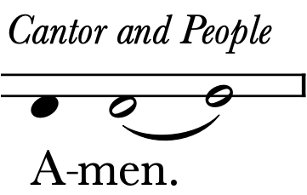
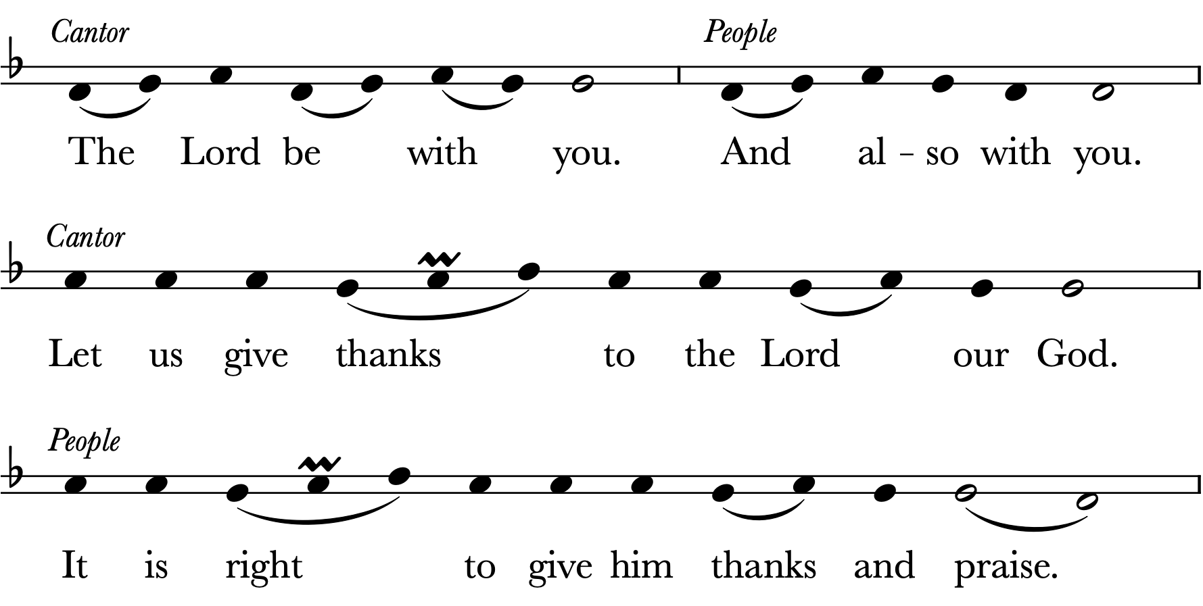
It is truly right and good, always and everywhere, with our whole heart and mind and voice, to praise you, the invisible, almighty, and eternal God, and your only-begotten Son, Jesus Christ our Lord; for he is the true Paschal Lamb, who at the feast of the Passover paid for us the debt of Adam’s sin, and by his blood delivered your faithful people.
This is the night, when you brought our fathers, the children of Israel, out of bondage in Egypt, and led them through the Red Sea on dry land. This is the night, when all who believe in Christ are delivered from the gloom of sin, and are restored to grace and holiness of life. This is the night, when Christ broke the bonds of death and hell, and rose victorious from the grave.
How wonderful and beyond our knowing, O God, is your mercy and loving-kindness to us, that to redeem a slave, you gave a Son. How holy is this night, when wickedness is put to flight, and sin is washed away. It restores innocence to the fallen, and joy to those who mourn. It casts out pride and hatred, and brings peace and concord. How blessed is this night, when earth and heaven are joined and man is reconciled to God.
Holy Father, accept our evening sacrifice, the offering of this candle in your honor. May it shine continually to drive away all darkness. May Christ, the Morning Star who knows no setting, find it ever burning—he who gives his light to all creation, and who lives and reigns for ever and ever.

The Liturgy of the Word
The Celebrant introduces the Scripture readings, saying
Brothers and sisters, it was the custom of the early Church to gather before the dawn of Easter’s first light, and to recount the ancient stories of our faith. Let us hear anew the record of God’s saving deeds in history, how he saved his people in ages past; and let us pray that our God will bring each of us to the fullness of redemption.

The Story of Creation
[Genesis 1:1—2:2]

Laurye Messer
The People join the reader in the following responsive reading.
Reader In the beginning, on the first day, God created the heavens and the earth. God said, “Let there be light,” and there was light. And God saw that it was good.
People Blessed be the God of radiance and warmth, of energy and hope;
Blessed be the God of light.
Reader In the beginning, on the second day, God created a dome to separate the waters from the waters. God called the dome “sky” and saw that it was good.
People Blessed be the God of rain and rivers, of water and air;
Blessed be the God of the ocean and sky.
Reader In the beginning, on the third day, God gathered the waters together and caused dry land to appear. God spoke, and the fertile earth brought forth every shade of green and every blossom in all their vibrant colors, and God saw that it was good.
People Blessed be the God of the flowers in their splendor,
the trees in their majesty and strength;
Blessed be the God of the green-brown earth.
Reader In the beginning, on the fourth day, God created the sun, the moon and the stars, to separate day from night, to mark the seasons. And God saw that it was good.
People Blessed be the God of signs and of seasons, of night and day;
Blessed be the God of the heavens and of time.
Reader In the beginning, on the fifth day, God created all the living creatures of sea and sky, and blessed them, and called them good.
People Blessed be the God of swimming and scales, of feathers and flight;
Blessed be the God of the creatures of sea and sky.
Reader In the beginning, on the sixth day, God created the animals of the earth, and made humankind in the image of God, and God saw that it was very good.
People Blessed be the God of flesh and bone, of souls that live and love;
Blessed be the God of the animals and of all humankind.
Reader In the beginning, on the seventh day, God created rest, and entered into a rest from all the work that had been done. And God saw that rest was very, very good, indeed.
People Blessed be the God of renewal and peace, of leisure and play;
Blessed be the God of holy sabbath rest.
Reader Blessed be God, O you people! Blessed be God!
People Blessed be God, Ruler of the ages!
Blessed be God, now and forevermore! Amen.

All stand as they are able and sing the following.
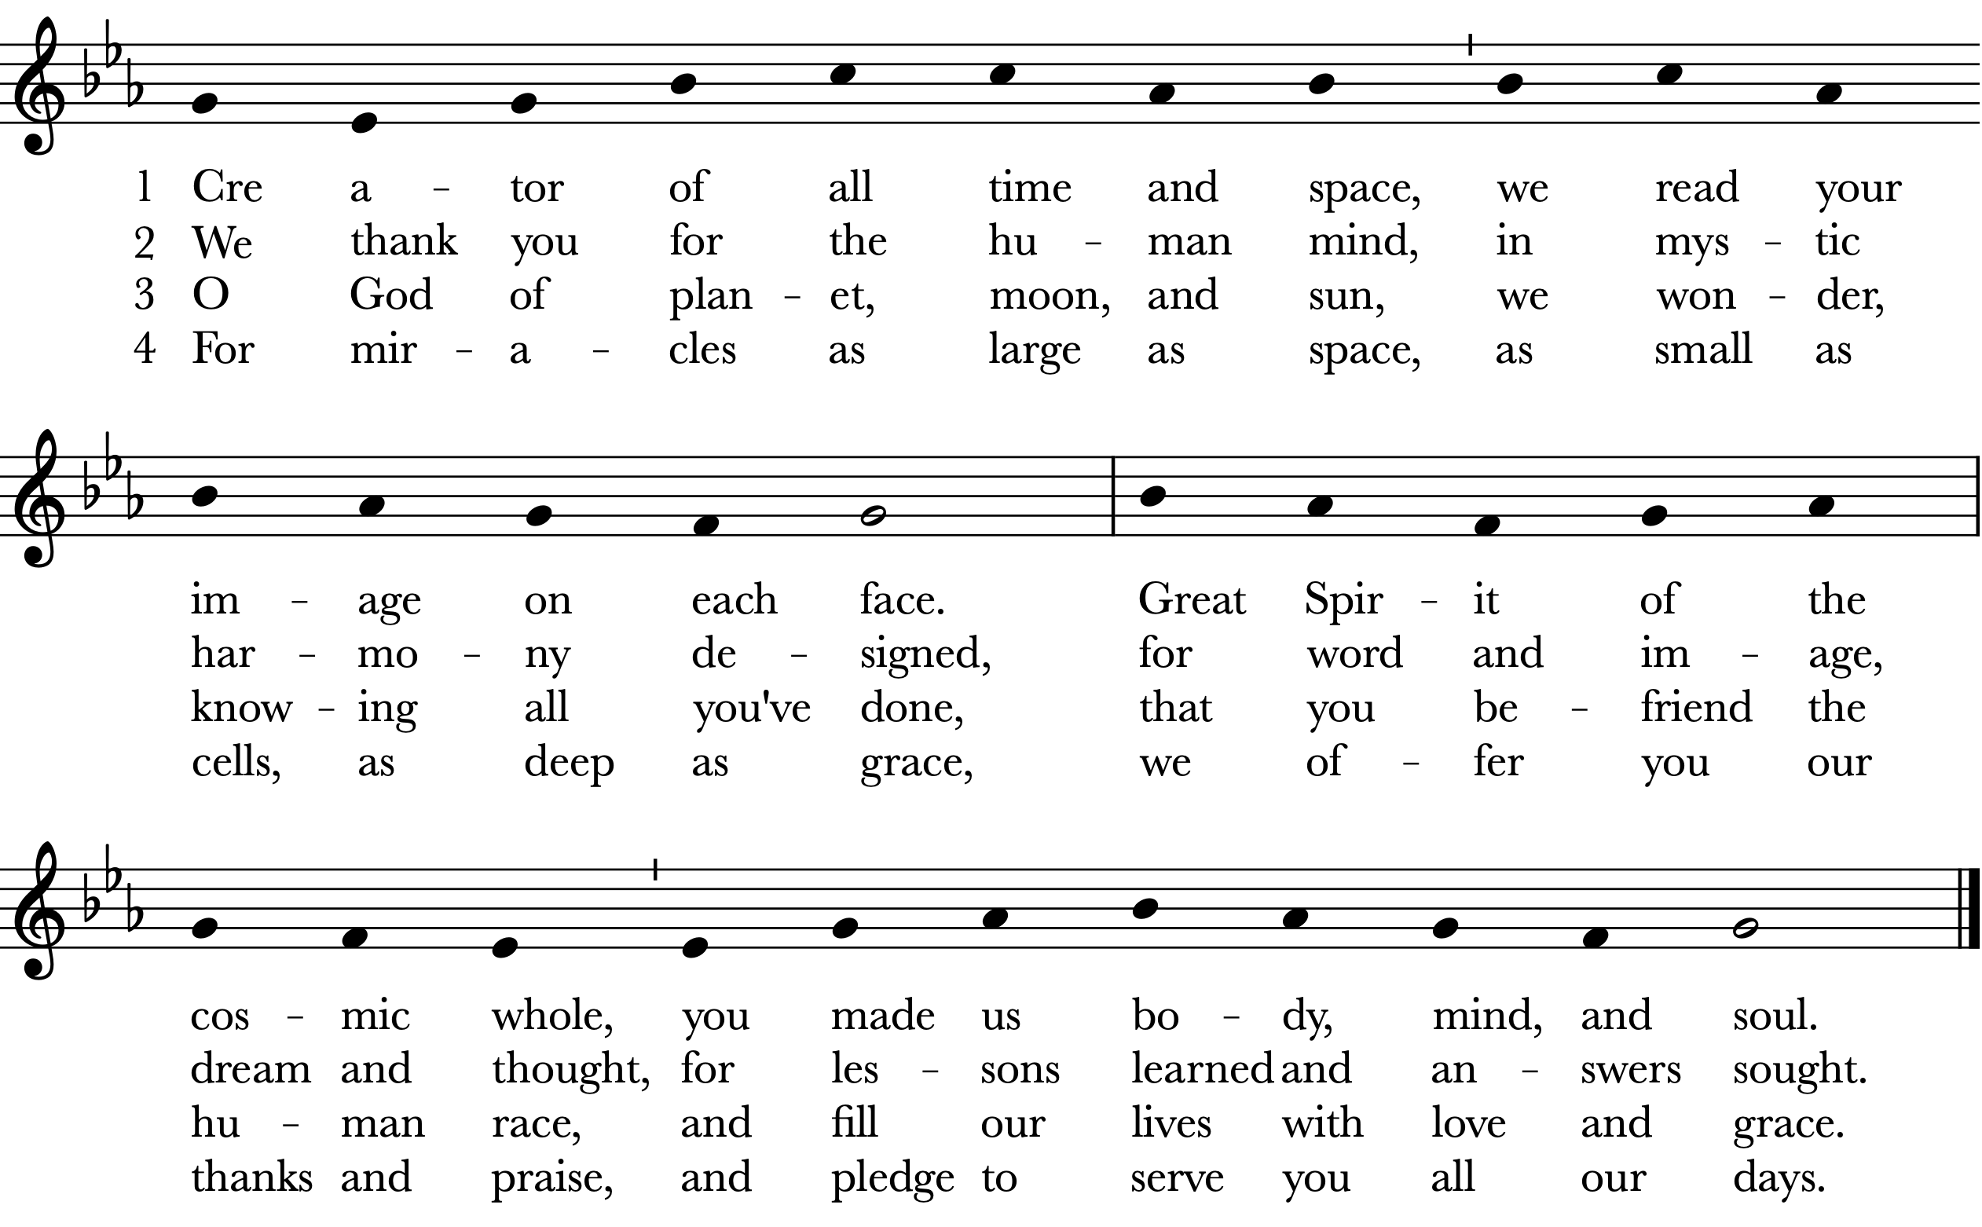
The Celebrant says
Let us pray. (Silence)
O God, who wonderfully created, and yet more wonderfully restored, the dignity of human nature: Grant that we may share the divine life of him who humbled himself to share our humanity, your Son Jesus Christ our Lord. Amen.
Noah and the Flood
[Genesis 7:1-5,11-18; 8:6-18; 9:8-13]
Christine Hanson, Jeff Couch & Anna Blalock
The readers appointed tell the story of Noah and the flood.

After the reading, all stand as they are able and sing the following.
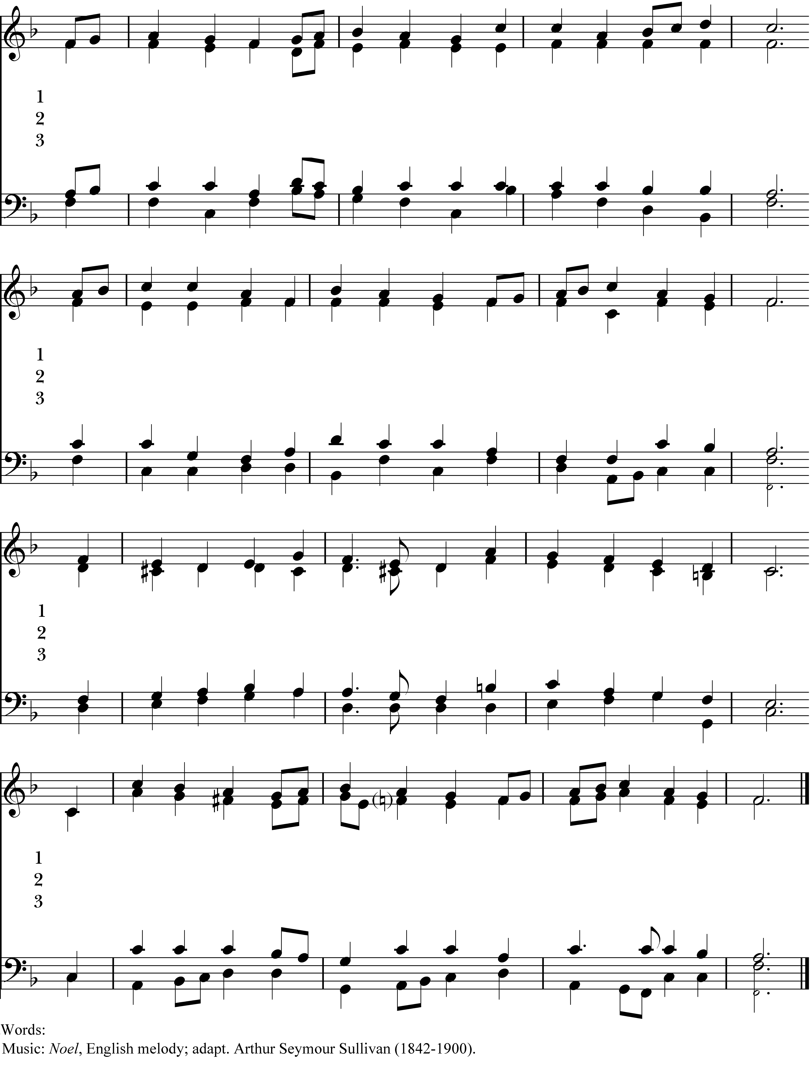
O God, who gives us life and breath, who shapes us in the womb,
O God, who calls your peo - ple out, to ven - ture and to dare,
O God of cov - e - nant and law, re - vealed in cloud and flame,
who guards our lives from birth to death, then leads us from the tomb:
to plumb the bleak a - byss of doubt and find you ev - en there:
your might - y deeds e - voke our awe; we dare not speak your Name.
De - liv - er us from fears that kill the life we have from you.
When we de - spair in wan - der - ing through wastes of emp - ty lies,
Yet we by faith are drawn to you and will your peo - ple prove,
Help us to know your Spi - rit still is mak - ing all things new.
Re - fresh us with the liv - ing spring of hope that ne - ver dies.
As on our hearts you write a - new the cov - e - nant of love.
Carl P. Daw, Jr. b. 1944, © 1990 Hope Publishing Company
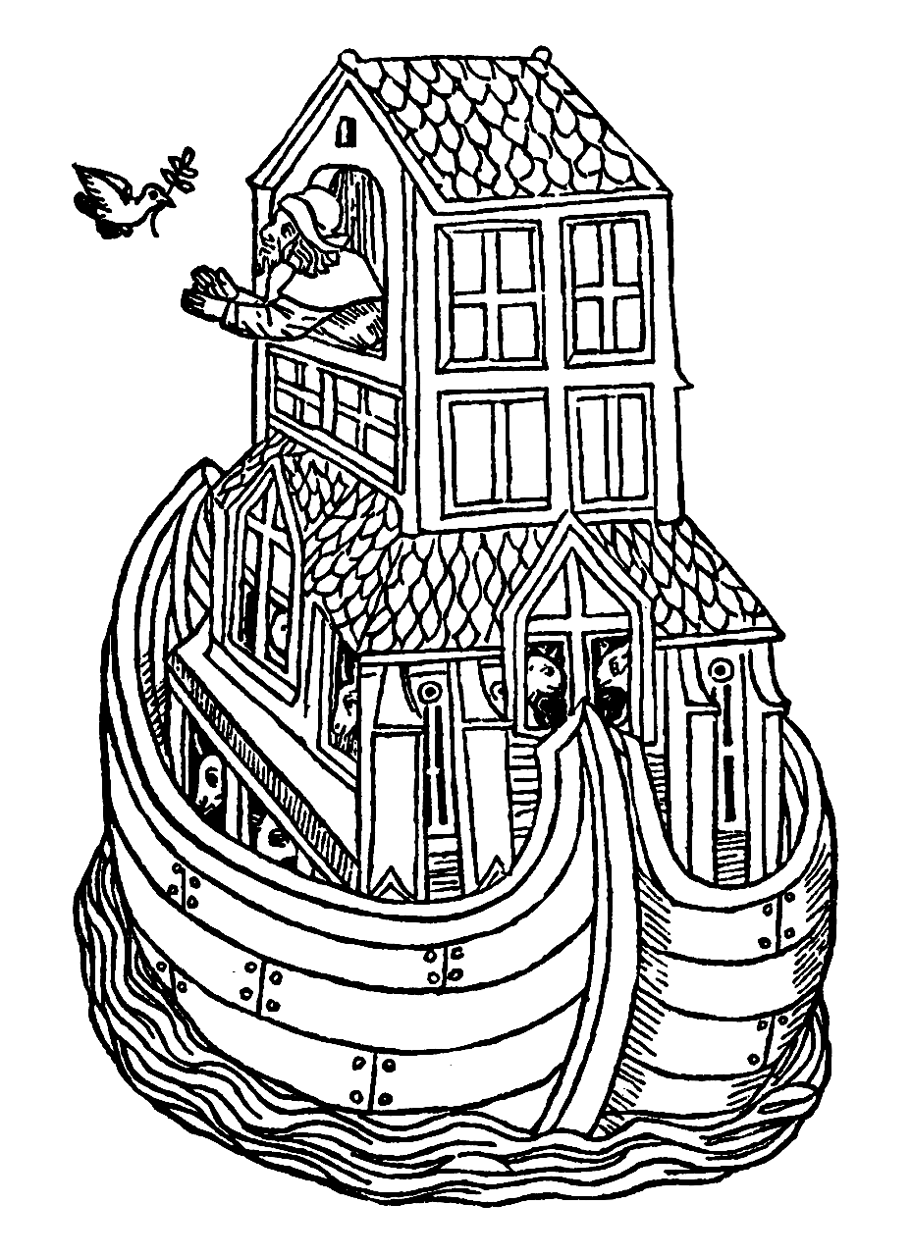

The Celebrant says
Let us pray. (Silence)
Almighty God, you have placed in the skies the sign of your covenant with all living things: Grant that we, who are saved through water and the Spirit, may worthily offer to you our sacrifice of thanksgiving; through Jesus Christ our Lord. Amen.

Elijah and the Prophets of Ba’al
[1 Kings 18:20-39]

Cindy Sessions & Kyle Griffis
The People join the appointed readers in the following responsive reading.
Narrator In those days, during the reign of King Ahab and Jezebel, the people of Israel lost their way. Not only did they worship the Lord their God, but they also began to worship the foreign god Ba’al. And so it came to pass that the prophet Elijah gathered all the people, and said,

Elijah Just how long are you all going to go limping around with two different opinions? If the Lord is God, then follow him; but if Ba’al is God, then follow him.

Narrator The people answered him not a word. Then Elijah said unto the people,

Elijah Let us put this matter to a test. You know that I, even I only, remain a prophet of the Lord; but Ba’al has four hundred and fifty prophets working for him. Let us take two bulls, then. The prophets of Ba’al may choose a bull for themselves, cut it into pieces, and lay it on the wood of the altar. But they shall not set fire to it.

And I, the prophet of the Lord, will do the same. I will cut the other bull and lay it on wood of the altar, but I will not set fire to it. Then all of you can call on the name of your gods while I call on the name of the Lord: and the God who answers with fire, let him be God!

Narrator And all the people answered saying,

People Yes! Yes! So say we all!

Narrator And so Elijah said to the prophets of Ba’al,

Elijah Go and choose a bull for yourselves, and since there are so many of you, prepare your bull first. Then call on the name of your god, but do not put any fire to the altar.

Narrator And so the prophets of Ba’al took the bull which they had chosen. They dressed it, placed it on the altar, and called on the name of Ba’al from morning until noon, yelling loudly,

People Hear us, O Ba’al!
Hear us, O Ba’al!

Narrator But there was no voice, nor any that answered. And the prophets of Ba’al leaped and danced upon the altar which had been made. At noonday Elijah began mocking them, saying,

Elijah Yes! Yes! Cry aloud and make your noise, for surely your god can hear you! Perhaps he has just gone off to meditate somewhere. Maybe he has wandered off on a journey or is away on vacation. Perhaps he’s on the toilet! Maybe your god is asleep and needs you to wake him up!

Narrator And so they cried louder, cutting themselves after their manner with knives and lancets, till the blood gushed out upon them. They continued to cry out,

People Hear us, O Ba’al!
Hear us, O Ba’al!

Narrator But still, there was no word, no answer, no response. And so Elijah said unto all the people,

Elijah Come near to me.

Narrator All the people came near to him, and Elijah repaired the altar of the Lord that was broken down. Then he took twelve stones, according to the number of the tribes of Israel, and with those stones he built an altar in the name of the Lord.

And Elijah dug a trench all around the altar, as great as would hold two full measures of grain. And he put the wood on the altar, cut the bull into pieces, laid it on the wood, and said,

Elijah Come! Fill up four barrels with water. Pour the water over the bull, over the wood, and over the whole altar.

Narrator The people did as he asked, and he said,

Elijah Do it again!

Narrator So they did it a second time, and he said,

Elijah Do it again!

Narrator And they did it the third time so that the water soaked the altar and filled the trench all around it. Finally, at the time of the evening sacrifice, Elijah the prophet came near, and declared,

Elijah Lord God of Abraham, Isaac, and of Israel! Let it be known this day that you alone are God in Israel, and that I am your servant, and that I have done all these things according to your command. Hear me, O Lord, hear me, that this people may know that you are the Lord, and turn their heart back again!

Narrator Immediately, the fire of the Lord fell from heaven. It consumed the burnt sacrifice—and the wood, and the stones, and even the dust—and it licked up all the water that was in the trench. And when all the people saw it, they fell on their faces, and they declared in a loud voice,

People The Lord, he is God!
The Lord, he is God!
The Lord, he is God!
Amen.

All stand as they are able and sing the following.
As now the sun shines down at noon, your
E - li - jah taunt - ed Baal at noon, he
O God, cre - a - tion’s rul - ing force, O
light, O Lord, burns in our hearts; as - sist us to en –
knew you, Lord, would an - swer him; may we, too, trust your
Je - sus, cru - ci - fied for us, O Spi - rit, bring - ing
dure that light, and through your judg - ment find your grace.
sover - eign pow’r when we must act in day’s hard light.
truth and love, we praise and bless you ev - ery hour.

The Celebrant says
Let us pray. (Silence)

Almighty God, you alone can bring into order the unruly wills and affections of sinners: Grant your people grace to love what you command and desire what you promise; that, among the swift and varied changes of the world, our hearts may surely there be fixed where true joys are to be found; through Jesus Christ our Lord, who lives and reigns with you and the Holy Spirit, one God, now and for ever. Amen.

Israel’s Deliverance at the Red Sea
[Exodus 14:10—15:1]

Pam Jordan Anderson, Allison Manausa & Ben Bowersox
The People join the appointed readers in the following responsive reading.
Reader 1 Why is this night different from all other nights?
People This is the Passover of the Lord, when God led us out of slavery in Egypt, through the Red Sea, onto dry ground.
We remember . . .
Reader 2 how we were slaves for four hundred years in Egypt, where we were treated harshly.
People We cried out to the Lord!
He heard us and sent our Father Moses to deliver us.
Reader 1 God said to Moses, “Tell old Pharaoh . . .
People to let my people go!”
Moses But who was I to go? I did not know how to speak to Pharaoh, nor how to prove that God had sent me. When Pharaoh would not listen, God sent plagues upon the Egyptians. There were frogs, and lice, and flies.
People There were boils, and hailstorms, and locusts.
There was a thick darkness, heavy as a shroud.
Reader 2 Then the worst and most rending plague of all, the death of every firstborn in all the land of Egypt.
Moses God said to me, “Instruct my people to eat their last meal in Egypt. Tell them to take one lamb for every family and roast it. Tell them to eat it in haste.”
People We ate it with unleavened bread and bitter herbs, with our sandals on our feet and our walking sticks in our hands. We remember . . .
Reader 1 how we raised the blood of the lamb and smeared it on our doorposts, so the angel of death would pass over our homes.
Reader 2 And then we rose up and left the land of our oppression. We left so quickly . . .
People our dough was still rising, our kneading bowls were wrapped on our shoulders, our sleeping children were nestled in our arms. We remember . . .
Reader 1 how happy we were, until we came to the shores of the sea. And then, like frightened children, we forgot that it was the Lord our God who brought us this far, and we began to weep, and wail, and whine. We said . . .
People O Moses, were there no graves in Egypt that you brought us out here to die? We should never have left. How much better to live as slaves than to die in freedom!
Moses A great fear fell over the people, so strong that they longed for slavery once again. But God said:
Reader 2 “Moses! Tell my people, ‘Do not be afraid. Stand firm, for the Egyptians you see today, you will never see again. The Lord will fight for you. You have only to stand firm!’”
Reader 1 “Lift up your staff, Moses. Stretch out your hand over the sea and divide it.
The Israelites shall pass on firm, dry ground.”
People The Lord drove back the sea with a strong east wind that blew all night, and turned the sea to dry land. We remember . . .
Moses how the pillar of cloud went before us and behind us, and when Pharaoh’s army came after us, the Lord looked down and threw them into panic. God said:
Reader 2 “Moses, stretch out your hand again so the waters of the sea may return
to their place.”
Moses Thus I did, and the Pharaoh’s army was drowned in the sea.
People Then we feared the Lord, and believed in his servant Moses.
Moses And when we arrived safely on the shore, our mothers danced and our sisters sang all through the night . . .
People because God delivered us from the bondage of slavery
and led us through the sea on dry foot.
The Lord brought us home to the land of promise.
Readers This is the Passover of the Lord . . .
People . . . and we remember!
We remember!
We remember!
Amen.

All stand as they are able and sing the following.
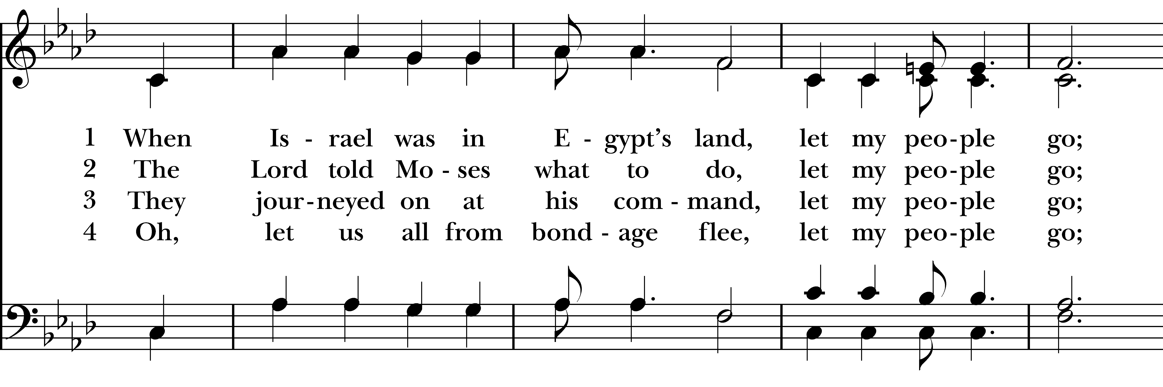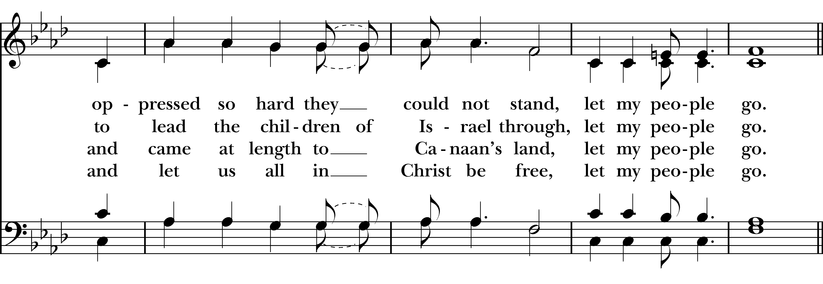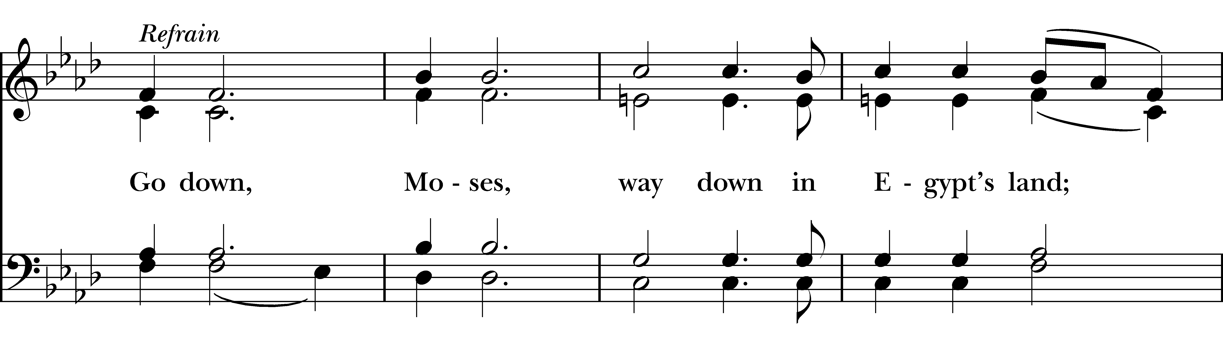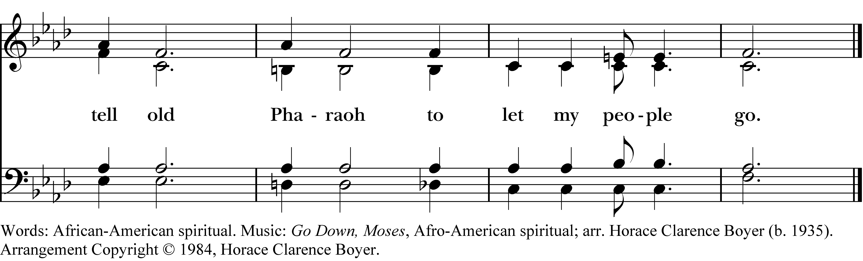
The Celebrant says
Let us pray. (Silence)
O God, whose wonderful deeds of old shine forth even to our own day, you once delivered by the power of your mighty arm your chosen people from slavery under Pharaoh, to be a sign for us of the salvation of all nations by the water of Baptism: Grant that all the peoples of the earth may be numbered among the offspring of Abraham, and rejoice in the inheritance of Israel; through Jesus Christ our Lord. Amen.

Holy Baptism

The Procession to the Baptismal Waters
The Celebrant says
Through the Paschal mystery, dear friends, we are buried with Christ by Baptism into his death, and raised with him to newness of life. Now as our Lenten observance draws to an end, let us join with those who have come to be baptized on this night and renew our solemn vows by which we, too, have joined the family of God.
All sing the following as the celebrant, candidates, and sponsors process to the baptismal font.

The Presentation of Candidates
When all are in place, the Celebrant says
The Candidates for Holy Baptism will now be presented.
Anthony Boyan Bonev
Stephanie Boyana Bonev
William Scott Childers
Kai Herbin
Wesley Aaron Hunter
Emma Hill Smith
Olivia Sperry
Adults and Older Children
The candidates who are able to answer for themselves are presented individually, as follows
Sponsors I present N. to receive the Sacrament of Baptism.
Celebrant N., do you desire to be baptized?
Candidate I do.
Infants & Younger Children
Then the candidates unable to answer for themselves are presented individually, as follows
Parents and Godparents
I present N. to receive the Sacrament of Baptism.

Celebrant
Will you be responsible for seeing that the child you present is brought up
in the Christian faith and life?
Parents and Godparents
I will, with God’s help.
Celebrant
Will you by your prayers and witness help this child to grow into the full stature of Christ?
Parents and Godparents
I will, with God’s help.
Then the Celebrant asks the following questions of the candidates who can speak for themselves, and of the parents and godparents who speak on behalf of the infants and younger children.
Question Do you renounce Satan and all the spiritual forces
of wickedness that rebel against God?
Answer I renounce them.
Question Do you renounce the evil powers of this world which
corrupt and destroy the creatures of God?
Answer I renounce them.
Question Do you renounce all sinful desires that draw you from the love of God?
Answer I renounce them.
Question Do you turn to Jesus Christ and accept him as your Savior?
Answer I do.
Question Do you put your whole trust in his grace and love?
Answer I do.
Question Do you promise to follow and obey him as your Lord?
Answer I do.
The Celebrant addresses the congregation, saying
Will you who witness these vows do all in your power to support these persons
in their life in Christ?
People We will.
The Celebrant continues, saying
Let us join with those who are committing themselves to Christ and renew our own baptismal covenant.

The Baptismal Covenant
Celebrant Do you believe in God the Father?
People I believe in God, the Father almighty,
creator of heaven and earth.
Celebrant Do you believe in Jesus Christ, the Son of God?
People I believe in Jesus Christ, his only Son, our Lord.
He was conceived by the power of the Holy Spirit
and born of the Virgin Mary.
He suffered under Pontius Pilate,
was crucified, died, and was buried.
He descended to the dead.
On the third day he rose again.
He ascended into heaven,
and is seated at the right hand of the Father.
He will come again to judge the living and the dead.
Celebrant Do you believe in God the Holy Spirit?
People I believe in the Holy Spirit,
the holy catholic Church,
the communion of saints,
the forgiveness of sins,
the resurrection of the body,
and the life everlasting.
Celebrant Will you continue in the apostles’ teaching and fellowship,
in the breaking of bread, and in the prayers?
People I will, with God’s help.
Celebrant Will you persevere in resisting evil, and, whenever you fall into sin,
repent and return to the Lord?
People I will, with God’s help.
Celebrant Will you proclaim by word and example the Good News of God in Christ?
People I will, with God’s help.
Celebrant Will you seek and serve Christ in all persons, loving your neighbor as yourself?
People I will, with God’s help.
Celebrant Will you strive for justice and peace among all people, and respect
the dignity of every human being?
People I will, with God’s help.

Prayers for the Candidates
The Celebrant then says to the congregation
Let us now pray for these persons, who are to receive the Sacrament of new birth.
A Person appointed leads the following petitions
Leader Deliver them, O Lord, from the way of sin and death.
People Lord, hear our prayer.
Leader Open their hearts to your grace and truth.
People Lord, hear our prayer.
Leader Fill them with your holy and life-giving Spirit.
People Lord, hear our prayer.
Leader Keep them in the faith and communion of your holy Church.
People Lord, hear our prayer.
Leader Teach them to love others in the power of the Spirit.
People Lord, hear our prayer.
Leader Send them into the world in witness to your love.
People Lord, hear our prayer.
Leader Bring them to the fullness of your peace and glory.
People Lord, hear our prayer.
The Celebrant says
Grant, O Lord, that all who are baptized into the death of Jesus Christ your Son may live in the power of his resurrection and look for him to come again in glory; who lives and reigns now and for ever. Amen.

Thanksgiving over the Water
The Celebrant blesses the water, first saying
The Lord be with you.
People And also with you.
Celebrant Let us give thanks to the Lord our God.
People It is right to give him thanks and praise.
We thank you, Almighty God, for the gift of water. Over it the Holy Spirit moved in the beginning of creation. Through it you led the children of Israel out of their bondage in Egypt into the land of promise. In it your Son Jesus received the baptism of John and was anointed by the Holy Spirit as the Messiah, the Christ, to lead us, through his death and resurrection, from the bondage of sin into everlasting life.
We thank you, Father, for the water of Baptism. In it we are buried with Christ in his death. By it we share in his resurrection. Through it we are reborn by the Holy Spirit. Therefore in joyful obedience to your Son, we bring into his fellowship those who come to him in faith, baptizing them in the Name of the Father, and of the Son, and of the Holy Spirit.
At the following words, the Celebrant touches the water
Now sanctify this water, we pray you, by the power of your Holy Spirit, that those who here are cleansed from sin and born again may continue for ever in the risen life of Jesus Christ our Savior. To him, to you, and to the Holy Spirit, be all honor and glory, now and for ever. Amen.

The Baptisms
Each candidate is presented to the Celebrant, who then immerses, or pours water upon, the candidate, saying
N., I baptize you in the Name of the Father, and of the Son, and of the Holy Spirit. Amen.
Then the Celebrant places a hand on the person’s head, marking on the forehead the sign of the cross using Chrism and saying
N., you are sealed by the Holy Spirit in Baptism and marked as Christ’s own for ever. Amen.
When this action has been completed, the Celebrant prays over the newly baptized, saying
Let us pray.
Heavenly Father, we thank you that by water and the Holy Spirit you have bestowed upon these your servants the forgiveness of sin, and have raised them to the new life of grace. Sustain them, O Lord, in your Holy Spirit. Give them an inquiring and discerning heart, the courage to will and to persevere, a spirit to know and to love you, and the gift of joy and wonder in all your works. Amen.
Let us welcome the newly baptized.
Celebrant and People
We receive you into the household of God. Confess the faith of Christ crucified, proclaim his resurrection, and share with us in his eternal priesthood.

The Proclamation of Easter
The Celebrant then says
And now, dear friends, through the Paschal mystery, we have been buried with Christ in Baptism and raised with him to newness of life. Where, O death, is your victory? Where, O grave, is your sting?
Alleluia! Christ is risen!
People The Lord is risen indeed! Alleluia!
Celebrant Alleluia! Christ is risen!
People The Lord is risen indeed! Alleluia!
Celebrant Alleluia! Christ is risen!
People The Lord is risen indeed! Alleluia!
The PEOPLE CHEER and make a JOYFUL NOISE as the tower bells are rung.

The People extinguish their candles.

Children’s Chapel
During the following canticle, Pre-K through 3rd grade children depart down the main aisle with volunteers for Children’s Chapel.

The Pascha Nostrum
During the following canticle, the remaining candles and lamps are lit and the Celebrant asperges the people with holy water.

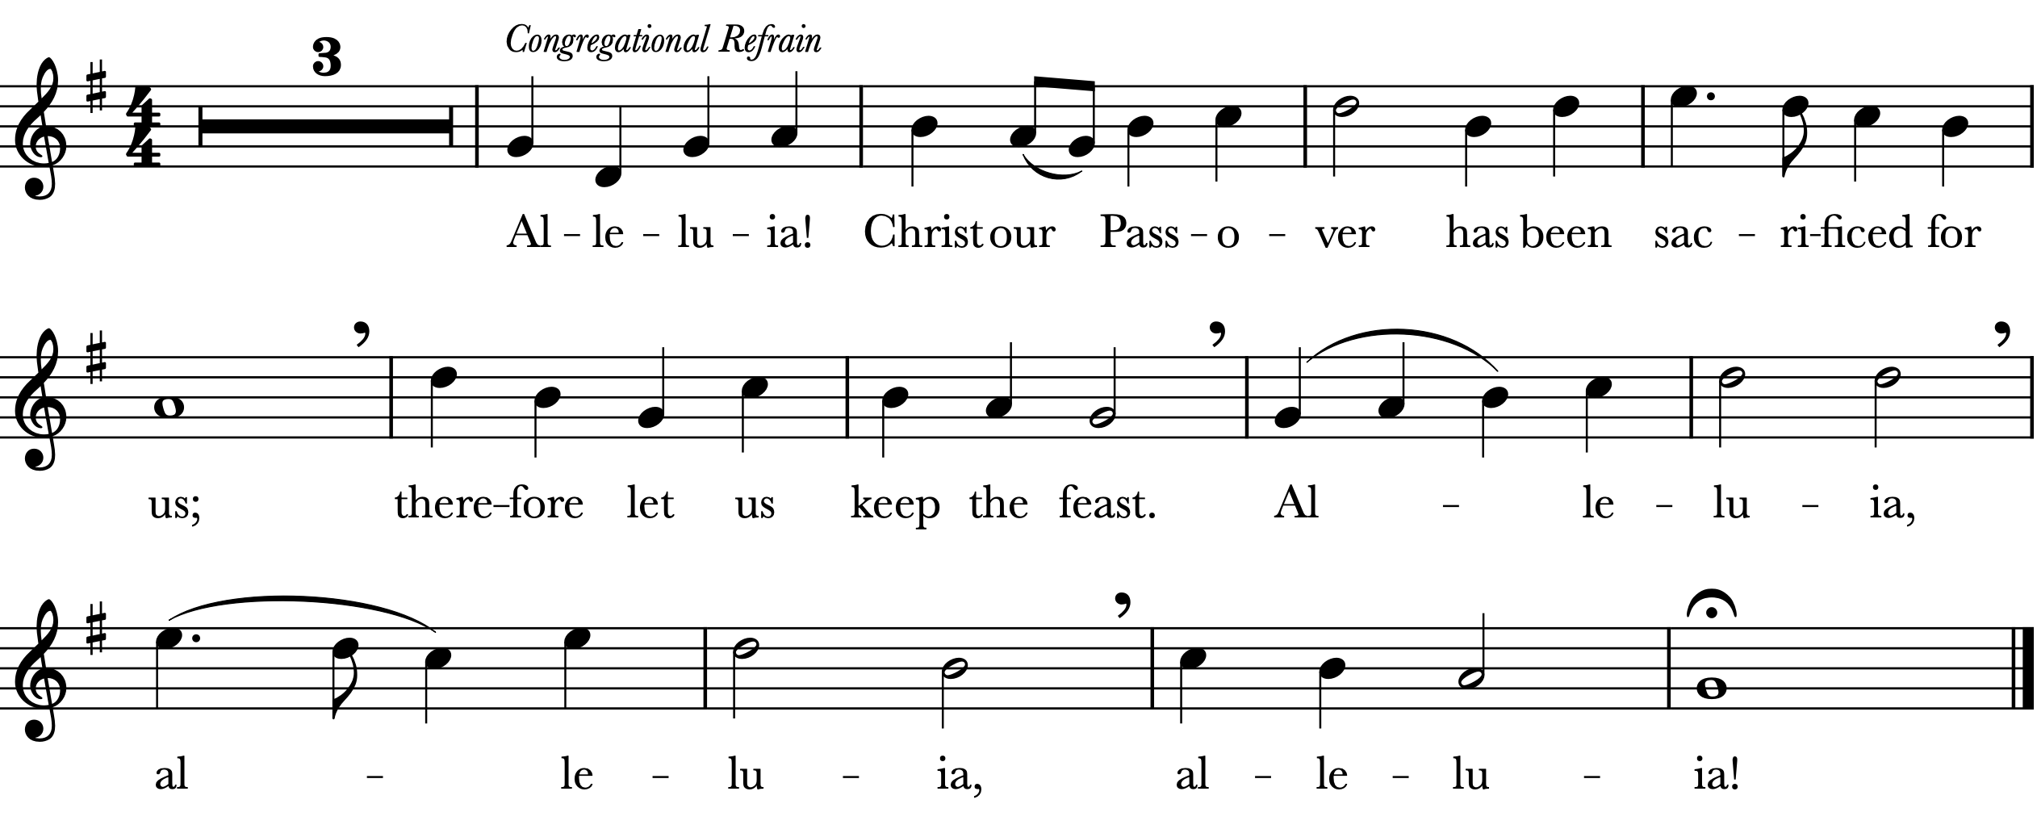
The Choir sings the following verses. All join in the refrain above.
Not with the old leaven, the leaven of malice and evil,
but with the unleavened bread of sincerity and truth. Alleluia. Refrain

Christ being raised from the dead will never die again; death no longer has dominion over him. The death that he died, he died to sin, once for all; but the life he lives, he lives to God. So also consider yourselves dead to sin, and alive to God in Jesus Christ our Lord. Alleluia. Refrain
Christ has been raised from the dead, the first fruits of those who have fallen asleep.
For since by a man came death, by a man has come also the resurrection of the dead.
For as in Adam all die, so also in Christ shall all be made alive. Alleluia. Refrain

The Epistle [Romans 6:3-11]
Do you not know that all of us who have been baptized into Christ Jesus were baptized into his death? Therefore we have been buried with him by baptism into death, so that, just as Christ was raised from the dead by the glory of the Father, so we too might walk in newness of life. For if we have been united with him in a death like his, we will certainly be united with him in a resurrection like his. We know that our old self was crucified with him so that the body of sin might be destroyed, and we might no longer be enslaved to sin. For whoever has died is freed from sin. But if we have died with Christ, we believe that we will also live with him. We know that Christ, being raised from the dead, will never die again; death no longer has dominion over him. The death he died, he died to sin, once for all; but the life he lives, he lives to God. So you also must consider yourselves dead to sin and alive to God in Christ Jesus.

The Word of the Lord.
People Thanks be to God.

All stand as they are able and sing the following.
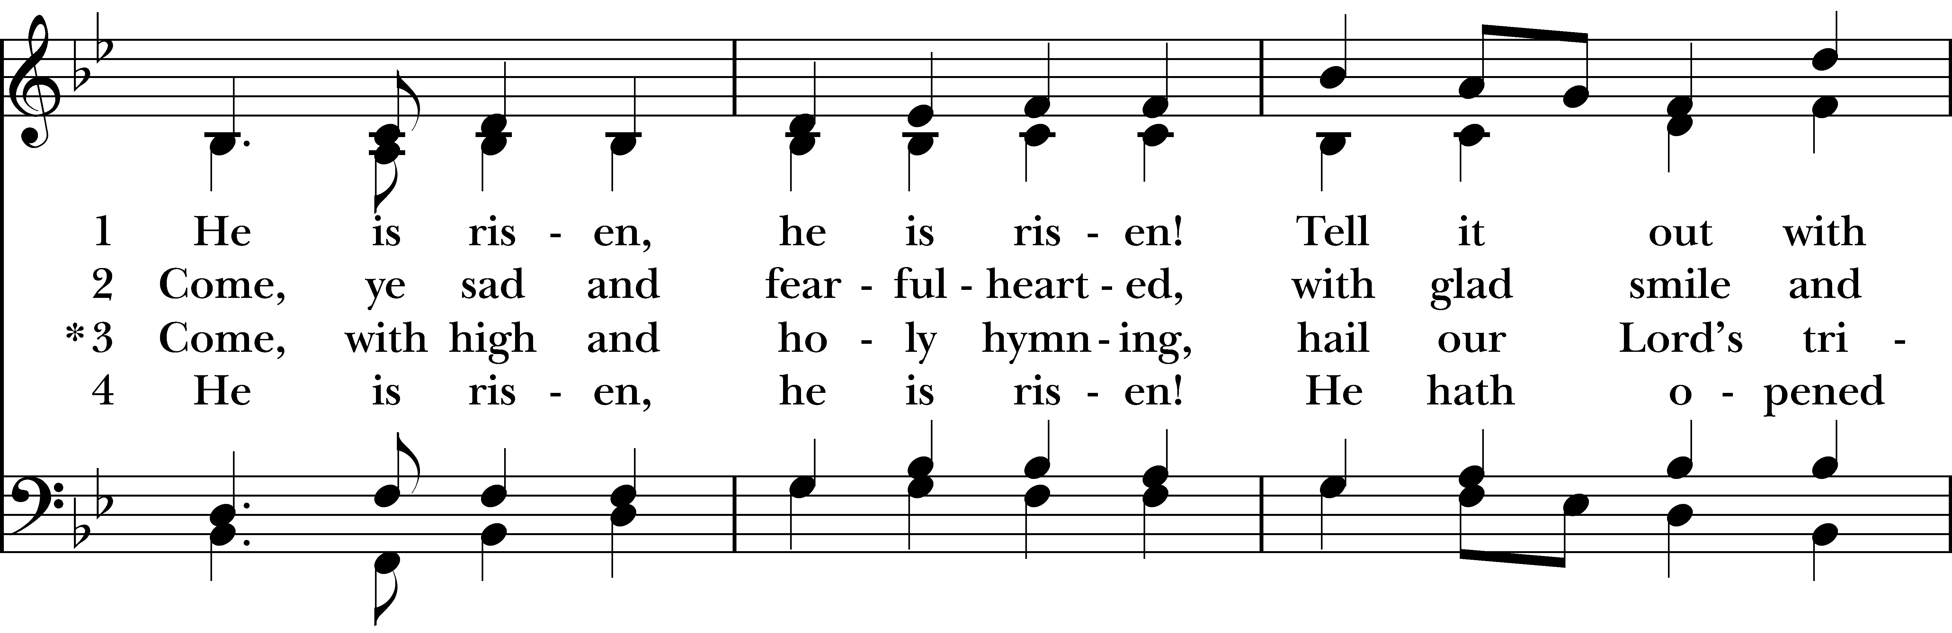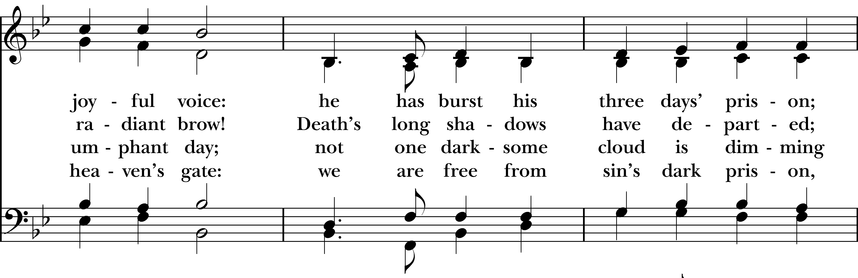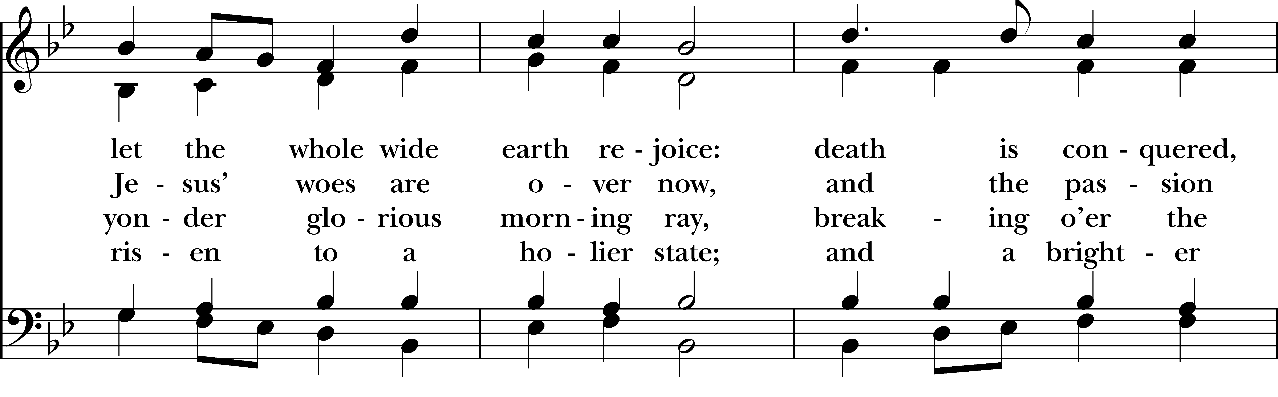
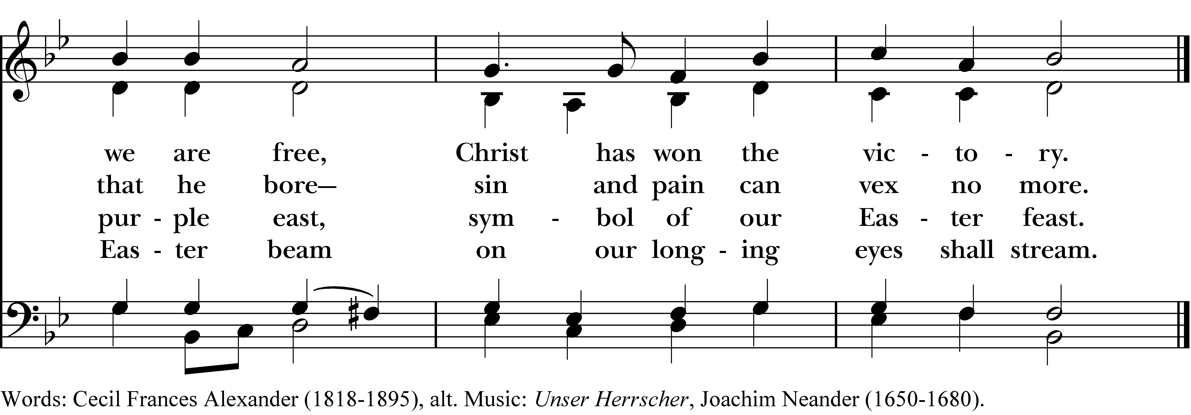
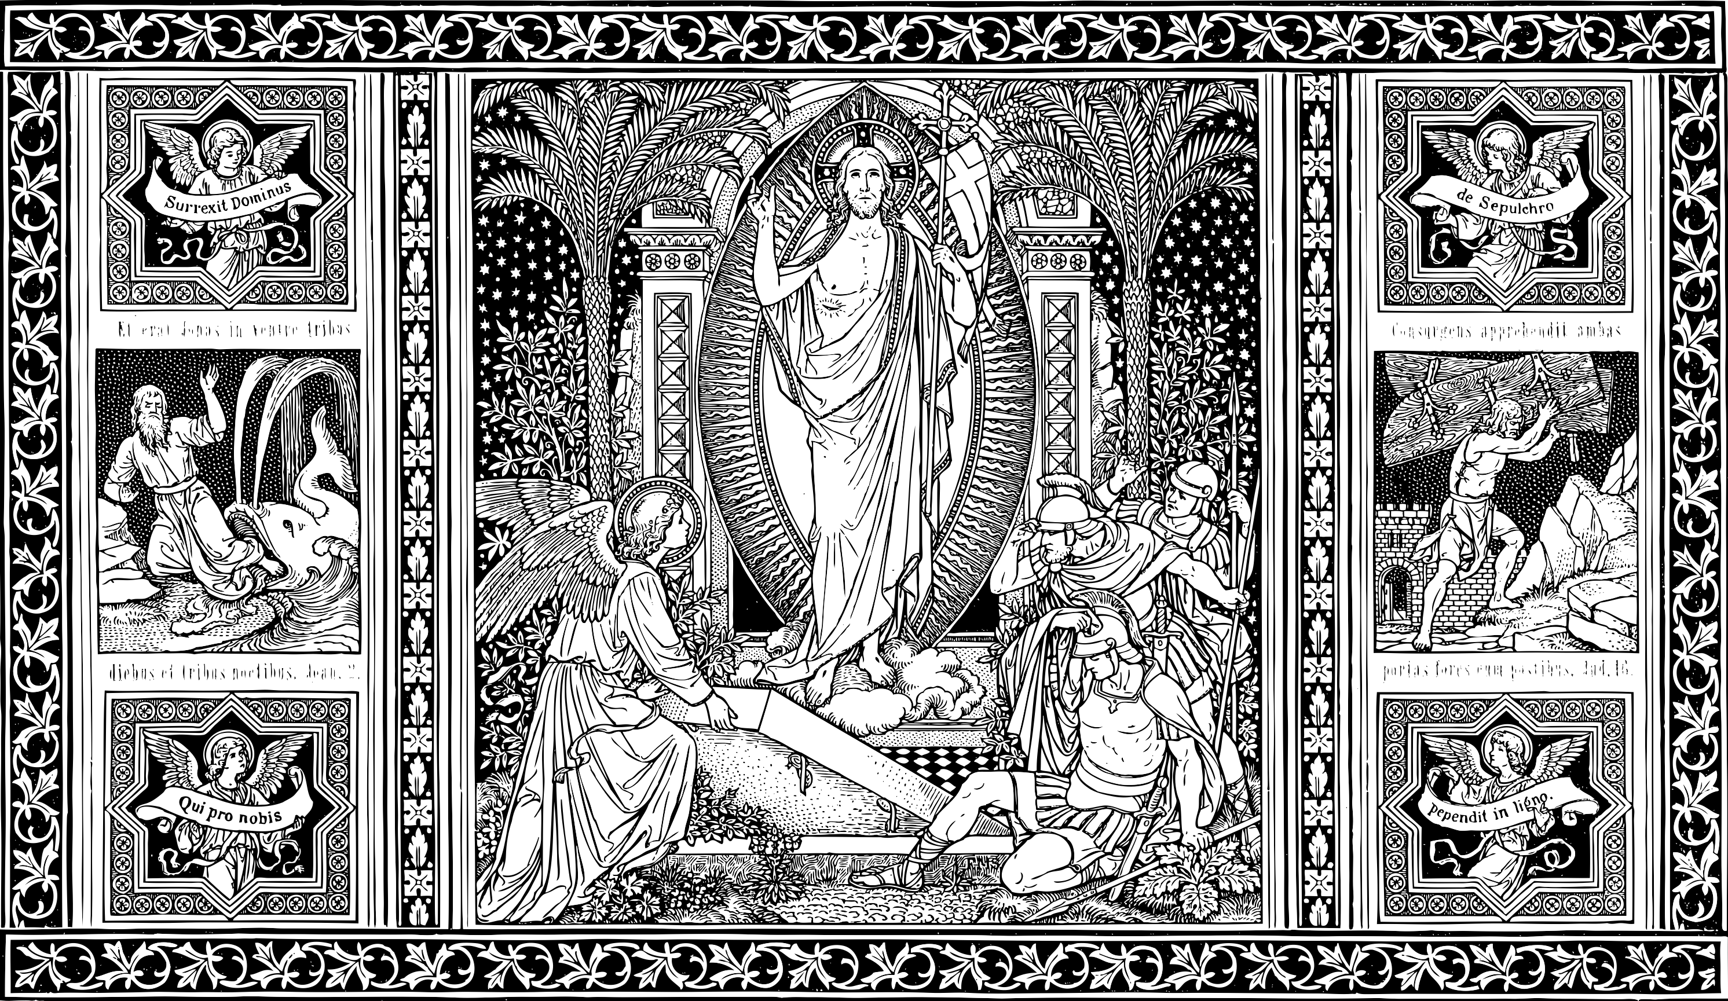
The Resurrection Gospel [Mark 16:1-8]
All standing as they are able, the Deacon reads the Gospel, first saying
The Holy Gospel of our Lord Jesus Christ according to Mark.
People Glory to you, Lord Christ.
When the sabbath was over, Mary Magdalene, and Mary the mother of James, and Salome
bought spices, so that they might go and anoint Jesus. And very early on the first day of the
week, when the sun had risen, they went to the tomb. They had been saying to one another,
Who will roll away the stone for us from the entrance to the tomb?” When they looked up,
they saw that the stone, which was very large, had already been rolled back. As they entered
the tomb, they saw a young man, dressed in a white robe, sitting on the right side; and they
were alarmed. But he said to them, “Do not be alarmed; you are looking for Jesus of
Nazareth, who was crucified. He has been raised; he is not here. Look, there is the place they
laid him. But go, tell his disciples and Peter that he is going ahead of you to Galilee; there you
will see him, just as he told you.” So they went out and fled from the tomb, for terror and
amazement had seized them; and they said nothing to anyone, for they were afraid.

The Gospel of the Lord.
People Praise to you, Lord Christ.

The Sermon The Rev. Lonnie Lacy

The Peace
All stand as they are able. The Celebrant says to the people
The peace of the Lord be always with you.
People And also with you.
Then the Ministers and People may greet one another in the name of the Lord.

Announcements

Offertory
Your gift in support of St. John’s makes all the difference, especially at this time of year.
Give tonight via the offering plate; or text STJOHNS to 73256; or scan this code with your phone to give online. You can also mail your gift to St. John’s Episcopal Church, Attn: Finance Office,
211 N. Monroe St., Tallahassee, FL 32301. Every gift, large or small, sustains the church you love.

Offertory Anthem
Ye choirs of new Jerusalem Charles Villiers Stanford

Ye choirs of new Jerusalem,
your sweetest notes employ,
the Paschal victory to hymn
in strains of holy joy.
For Judah’s Lion bursts his chains,
crushing the serpent’s head;
and cries aloud through death’s domains
to wake the imprisoned dead.
Devouring depths of hell their prey
at his command restore;
his ransomed hosts pursue their way
where Jesus goes before.

Triumphant in his glory now
to him all power is given;
to him in one communion bow
all saints in earth and Heaven.
While we, his soldiers, praise our King,
his mercy we implore,
within his palace bright to bring
and keep us evermore.
All glory to the Father be,
all glory to the Son,
all glory, Holy Ghost, to Thee,
while endless ages run.
Alleluia! Amen.

Text: St. Fulbert of Chartres, translated by Robert Campbell

Presentation of the Gifts
All stand as they are able.
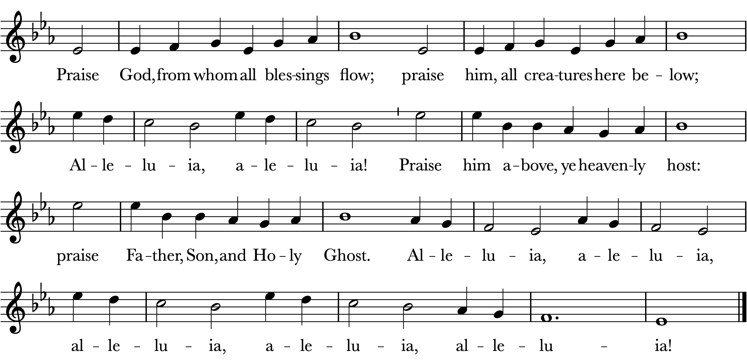

The First Eucharist of Easter
The people remain standing as they are able.
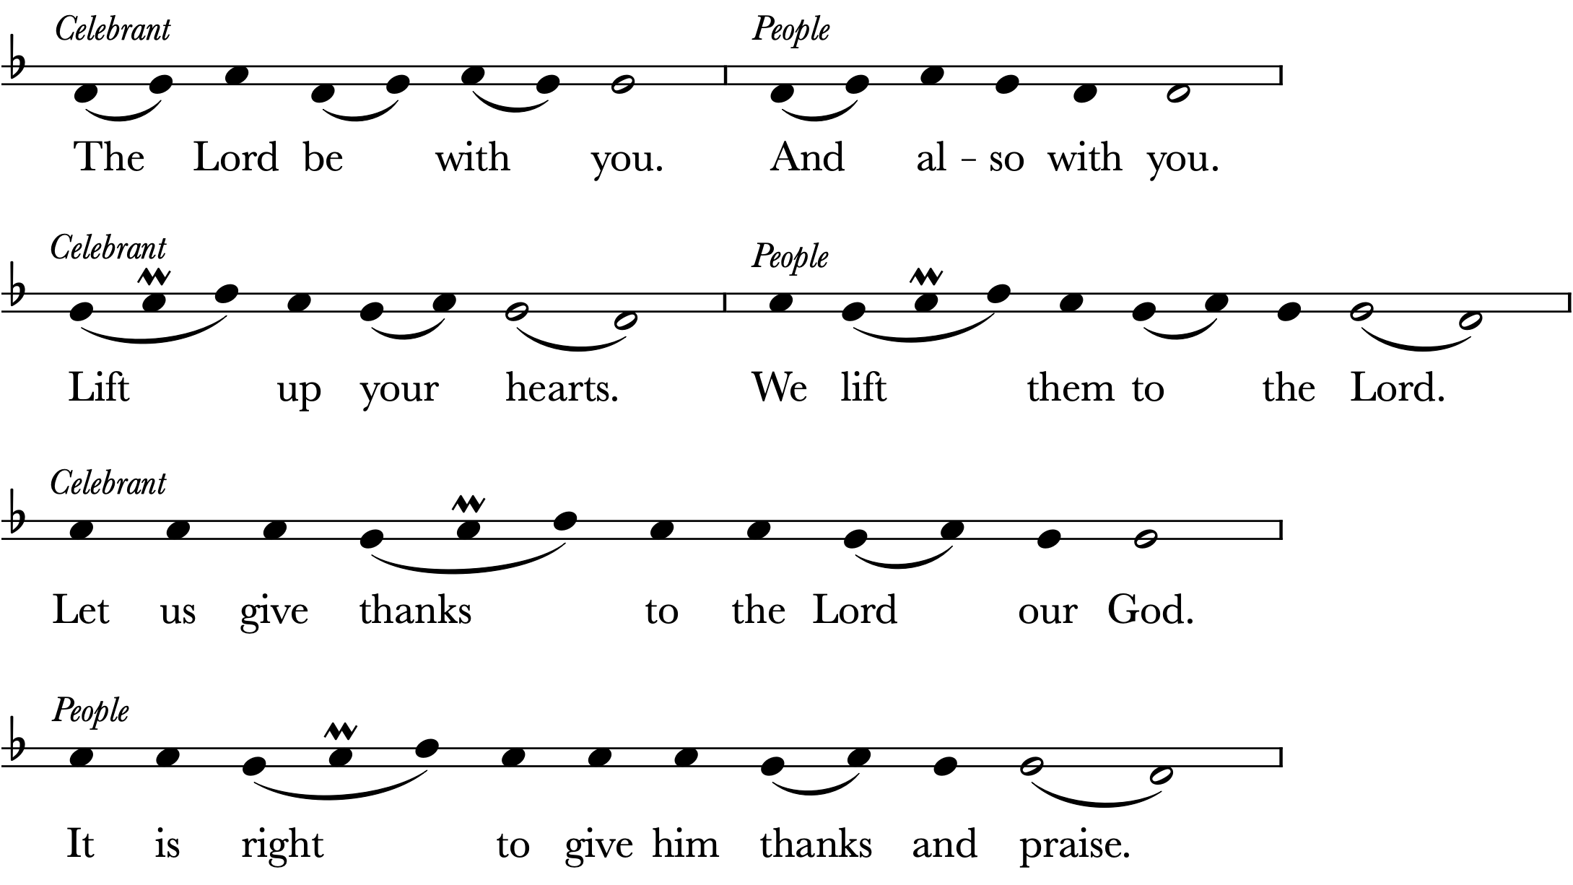

Facing the Holy Table, the Celebrant proceeds
It is truly right to glorify you, Father, and to give you thanks; for you alone are God, living and true, dwelling in light inaccessible from before time and for ever. Fountain of life and source of all goodness, you made all things and fill them with your blessing; you created them to rejoice in the splendor of your radiance. Countless throngs of angels stand before you to serve you night and day; and, beholding the glory of your presence, they offer you unceasing praise. Joining with them, and giving voice to every creature under heaven, we acclaim you, and glorify your Name, as we sing:
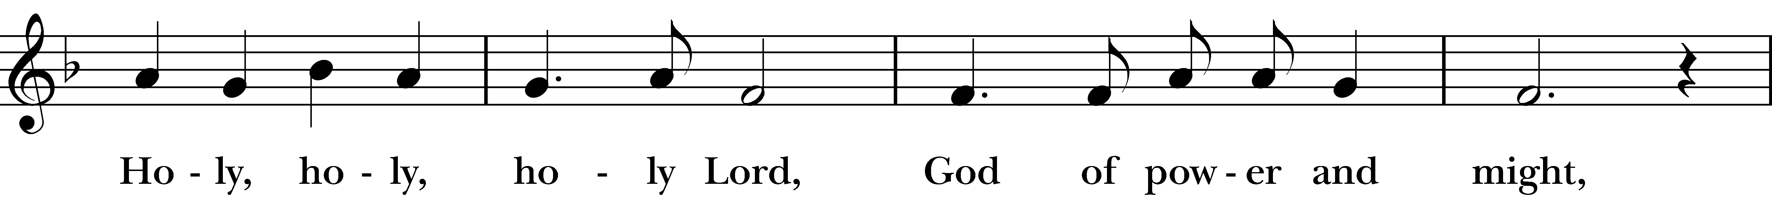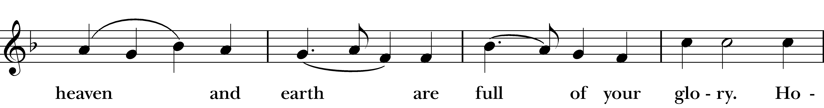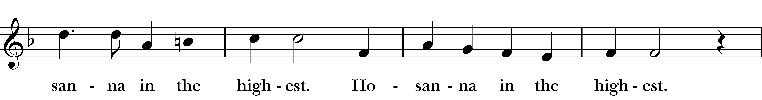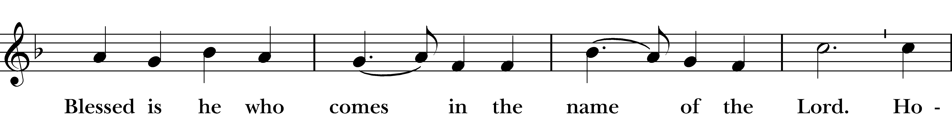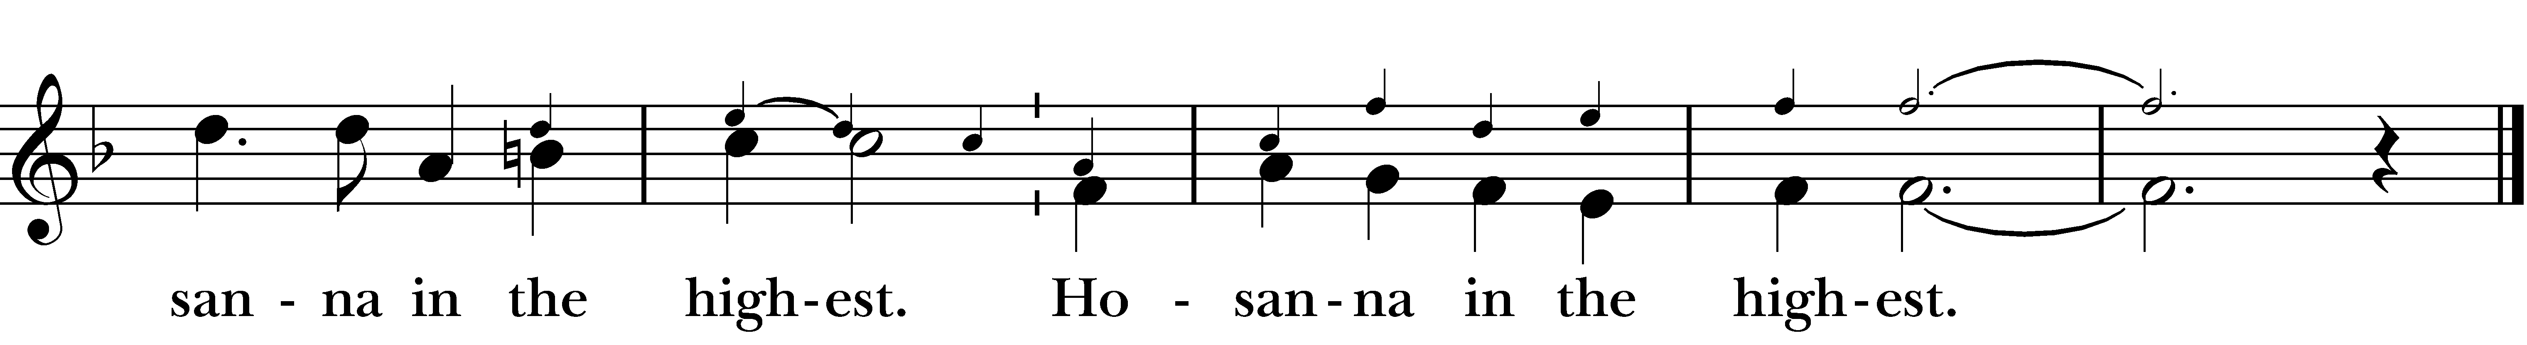
The people kneel as they are able. Then the Celebrant continues
We acclaim you, holy Lord, glorious in power. Your mighty works reveal your wisdom and love. You formed us in your own image, giving the whole world into our care, so that, in obedience to you, our Creator, we might rule and serve all your creatures. When our disobedience took us far from you, you did not abandon us to the power of death. In your mercy you came to our help, so that in seeking you we might find you. Again and again you called us into covenant with you, and through the prophets you taught us to hope for salvation.
Father, you loved the world so much that in the fullness of time you sent your only Son to be our Savior. Incarnate by the Holy Spirit, born of the Virgin Mary, he lived as one of us, yet without sin. To the poor he proclaimed the good news of salvation; to prisoners, freedom; to the sorrowful, joy. To fulfill your purpose he gave himself up to death; and, rising from the grave, destroyed death, and made the whole creation new. And, that we might live no longer for ourselves, but for him who died and rose for us, he sent the Holy Spirit, his own first gift for those who believe, to complete his work in the world, and to bring to fulfillment the sanctification of all.
At the following words concerning the bread, the Celebrant is to hold it or lay a hand upon it; and at the words concerning the cup, to hold or place a hand upon the cup and any other vessel containing wine to be consecrated.
When the hour had come for him to be glorified by you, his heavenly Father, having loved his own who were in the world, he loved them to the end; at supper with them he took bread, and when he had given thanks to you, he broke it, and gave it to his disciples, and said, “Take, eat: This is my Body, which is given for you. Do this for the remembrance of me.”
After supper he took the cup of wine; and when he had given thanks, he gave it to them, and said, “Drink this, all of you. This is my Blood of the new Covenant, which is shed for you and for many for the forgiveness of sins. Whenever you drink it, do this for the remembrance of me.”
Father, we now celebrate this memorial of our redemption. Recalling Christ’s death and his descent among the dead, proclaiming his resurrection and ascension to your right hand, awaiting his coming in glory; and offering to you, from the gifts you have given us, this bread and this cup, we praise you and we bless you.
Celebrant and People
We praise you, we bless you,
we give thanks to you,
and we pray to you, Lord our God.
The Celebrant continues
Lord, we pray that in your goodness and mercy your Holy Spirit may descend upon us, and upon these gifts, sanctifying them and showing them to be holy gifts for your holy people, the bread of life and the cup of salvation, the Body and Blood of your Son Jesus Christ.
Grant that all who share this bread and cup may become one body and one spirit, a living sacrifice in Christ, to the praise of your Name. Remember, Lord, your one holy catholic and apostolic Church, redeemed by the blood of your Christ. Reveal its unity, guard its faith, and preserve it in peace. And grant that we may find our inheritance with the Blessed Virgin Mary, with patriarchs, prophets, apostles, and martyrs, with St. John and all the saints who have found favor with you in ages past. We praise you in union with them and give you glory through your Son Jesus Christ our Lord.
Through Christ, and with Christ, and in Christ, all honor and glory are yours, Almighty God and Father, in the unity of the Holy Spirit, for ever and ever.
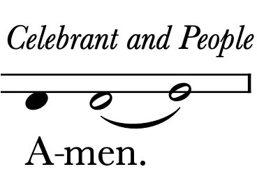

The Lord’s Prayer
And now, as our Savior Christ has taught us, we are bold to say,
People and Celebrant
Our Father, who art in heaven,
hallowed be thy Name,
thy kingdom come,
thy will be done,
on earth as it is in heaven.
Give us this day our daily bread.
And forgive us our trespasses,
as we forgive those who trespass against us.
And lead us not into temptation,
but deliver us from evil.
For thine is the kingdom, and the power, and the glory,
for ever and ever. Amen.

The Breaking of the Bread
The Celebrant breaks the consecrated Bread.
A period of silence is kept.

Fraction Anthem
Antiphon
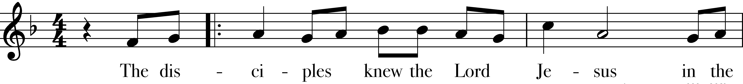

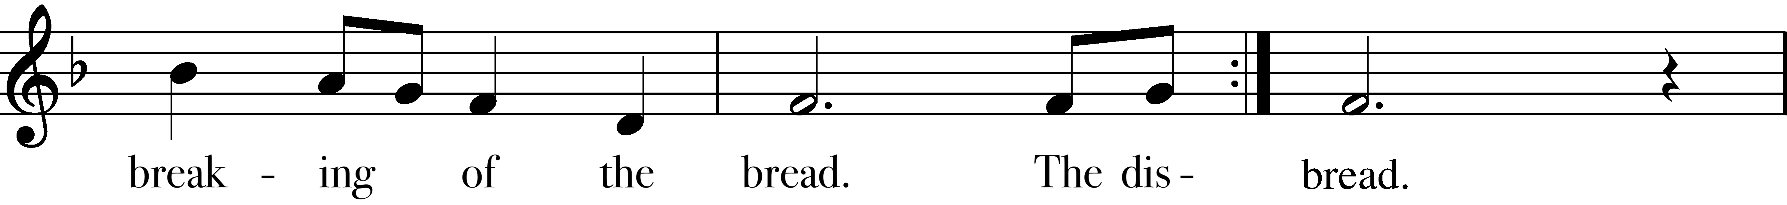

Choir
The bread which we break, alleluia,
is the communion of the body of Christ.
Antiphon

Facing the people, the Celebrant says the following Invitation
The Gifts of God for the People of God. Take them in remembrance that Christ died for you, and feed on him in your hearts by faith, with thanksgiving.

Communion Hymns

Christians, to the Paschal victim Hymn 183

Through the Red Sea brought at last 187

Come, ye faithful, raise the strain 200

Now the green blade riseth 204

The Communion of the People
Communion is central to our worship at St. John’s. All baptized Christians—regardless of age or denominational affiliation—are welcome to receive.
❶ Wait for guidance from the ushers.
At the appropriate time, an usher will invite the people in your
pew to rise and follow the line to the Communion rail or station.
Those with limited mobility may request that Communion be
brought directly to their pew.
❷ Kneel or stand.
Most people kneel at the rail to receive Communion, but
standing is also appropriate, especially if kneeling is difficult.
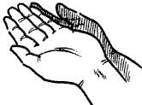
❸ Receive the bread.
As the minister approaches with the bread, extend
your hands with palms open and facing up. You may
consume the bread immediately or wait to have it
dipped in the wine.
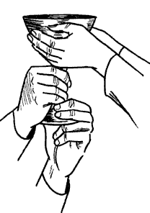
❹ Receive the wine.
The wine is served in a large chalice as a sign of
unity. Assist the lay minister by guiding the chalice
to your lips, holding it by the base, and take a small
sip. If you would rather not drink directly from the
chalice, you may offer your bread to the lay
minister and allow him or her to dip it in the wine
and hand it back to you to consume.
❺ Return to your pew.
Return to your pew, kneel if you like, sing with the
congregation, or offer your silent prayers to God.
If you are unbaptized or would prefer not to receive the bread or wine for any reason, cross your arms over your chest at the rail. This signifies to the priest that you wish to receive a blessing instead.

Communion Anthem
After Communion, all join in the following
Music: Calvin Hampton

Postcommunion Prayer
The Celebrant says
Let us pray.
Celebrant and People
Eternal God, heavenly Father,
you have graciously accepted us as living members
of your Son our Savior Jesus Christ,
and you have fed us with spiritual food
in the Sacrament of his Body and Blood.
Send us now into the world in peace,
and grant us strength and courage
to love and serve you
with gladness and singleness of heart;
through Christ our Lord. Amen.

The Blessing
The Celebrant says
May Almighty God, who has redeemed us and made us his children through the resurrection of his Son our Lord, bestow upon you the riches of his blessing. Amen.
May God, who through the water of baptism has raised us from sin into newness of life, make you holy and worthy to be united with Christ for ever. Amen.
May God, who has brought us out of bondage to sin into true and lasting freedom in the Redeemer, bring you to your eternal inheritance. Amen.
And the blessing of God Almighty, the Father, the Son, and the Holy Spirit, be upon you and remain with you for ever. Amen.

All stand as they are able.

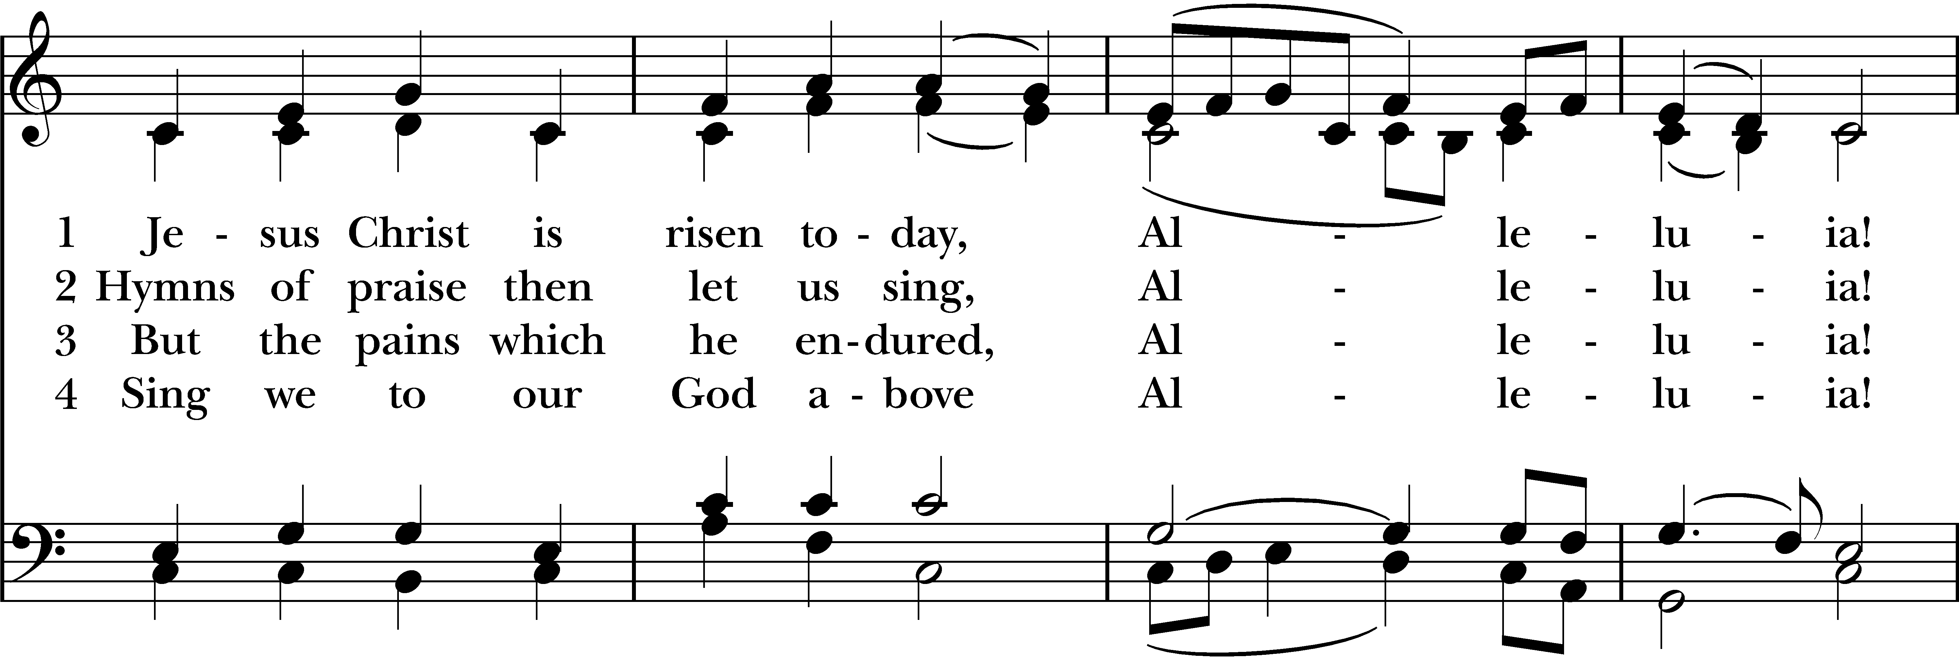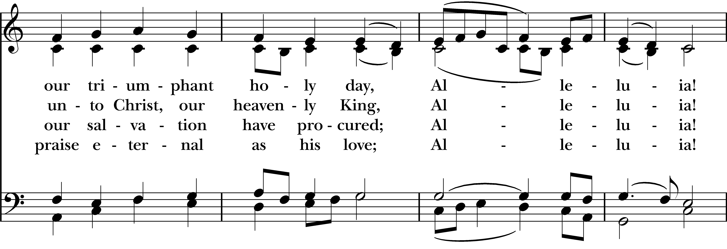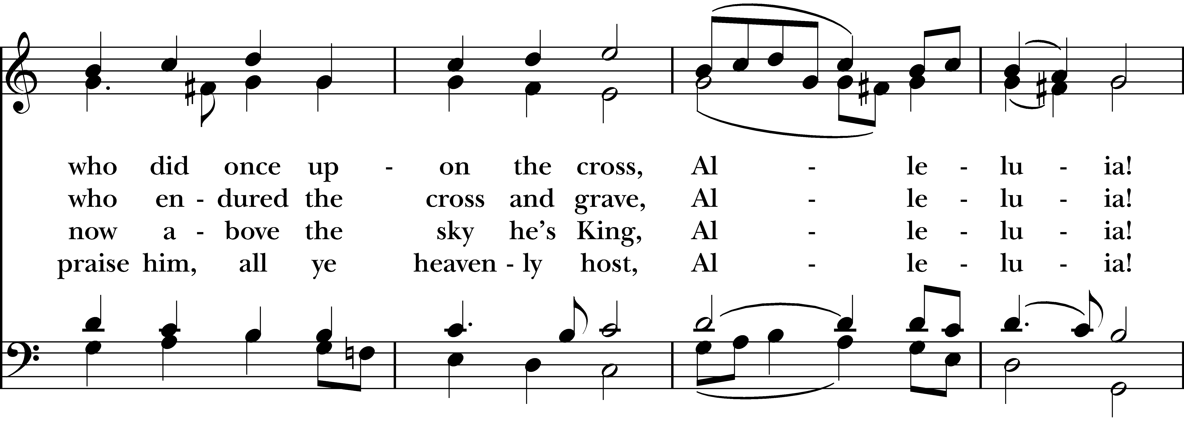

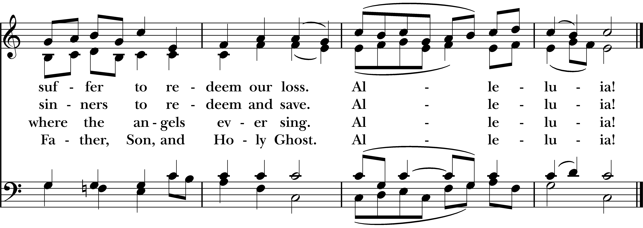

The Dismissal
The Deacon dismisses the people with these words
Go in peace to love and serve the Lord. Alleluia, alleluia!
People Thanks be to God. Alleluia, alleluia!

Postlude Carillon de Westminster

Louis Vierne

Tower Bells

Music reprinted by permission. ONE LICENSE #1-701991 and/or Christian Copyright Solutions, WorshipCast License #12900.

Easter lilies
have been given to the glory of God
in loving memory of:

Alvin and Annie Frazier by Hilda Frazier

Betty and Charlie James by Barbara James

Buddy & June Strauss, Charlie, Bob, Bobby & Barbara Redding by Charley & Leslie Redding

Dean Rhodes by Kristina Nilsson

Dennis Hamilton James by Barbara James

Donna Virnelson by the Daughters of the King

Edward & Joan Linney and Nathaniel & Kathleen Griffin by John & Jewel Linney

Edward Milton Farley III & Joan Farley Chappel by Dina Foster

Edwin Austen, George & Virginia Austermuhl and Isabelle Trainer by Carol Newman

Emery & Martha Maddox by daughter Kerry

Ervin and Clara by Richard & Jo Ann McAdams

Fentonette Langston from her children

Fr. Laughton Thomas by the Daughters of the King

George & Alta Briede, Claudine, Georgia Lee Powell, Steve Binns by Jim & Maureen Briede

George and Gladys Hargrave by Michael Hargrave

Herbert and Lucille Jones by Richard & Jo Ann McAdams

Hollis Powers by Janice Powers

Irene & Erwin Klein by Doc & Helen Klein Horton

Ivor & Peggy King, Granny Spencer, Myra, Chrissy, Aunty Ivy by Jim & Maureen Briede

Jack Kane, Sr., with love from Betty, your children, and grandchildren

Jane Porter Ashler, Phil & Elisa Ashler, Kenneth & Margaret Winstead by Phil & Betty Ashler

Jim Joanos by His Family

Jim Joanos by the Daughters for the King

John & Florence Andreshock, Cathrine & James Arthur & Anne Irvine, Nancy Dominy Rollis

John Klein Wigginton by Martha Gene Wigginton

Joyce Yancey Hawrahan & Wallace Glenn Yancey by Pat Martin

Kevin Carroll, with love from Lane’s friends

Louise & Ralph Ketcham and Diane, their daughter, by Hilda Frazier

Margaret Sanders by Marcy Muldrow Sanders

Martha & Alfred Bragg by Gene & Susan Adams

Michael Craig Simpkins by Kimberly Simpkins

My Parents, the Edmistens, by Pamela E. McWilliams

Orrell Nilsson by Kristina Nilsson

Our Grandparents, Buddy & Carolyn, Betty & Pete, Gladys, Tyree & Louise by Heather & Tyree Jordan

Our parents Bill & Mary Ella Sessions and Jim & Jimmie Lee Coram by Doug & Cindy Sessions

Our parents by Ash and Jan Williams

Our parents Harrold & Virginia Carswell and Bud & Peggy Carlson by Scott & Julie Carswell

Patricia Larkin Johnson by Barbara James

Peggy J Moffitt by Kimberly Simpkins

Phyllis Bauer Nelson by Linda Phyllis Nelson

Raymond Nilsson by Kristina Nilsson

Richard & Clara Bewerse, beloved parents, by Barbara Bewerse

Rosario Toledo given by Doug & Cindy Sessions

Rose & Norman H. Horton by Doc & Helen Horton

Rosetta & Emerson Tully by Susan & Martin Proctor and family

Sally Kreimer by her daughter, Caroline Jernigan

Sarah & Julian Proctor by Susan & Martin Proctor and family

Sarah & Omar Adams by Gene & Susan Adams

Sarah & Sammie Crowder by Susan & Martin Proctor and family

Steve & Helen C. Edwards by Ashley Edwards and Kim Hinckley

To the glory of God and in loving memory of our son William Gordon Dean by his parents, John & Teresa Dean

To the glory of God and in loving memory, our parents Gordon & Laura Long and William & Frances Dean by John & Teresa Dean

Warren R. Blount M.D. by Liz Blount

Wayne and Barbara Kiger, Seabie and Letha Rucker by Paula Kiger

Easter lilies
have been given to the glory of God
in thanksgiving for:

Betty Kane, with love from her children and grandchildren

Bill & Lottie Muldrow by Marcy Muldrow Sanders

Cynthia Paulson from the Paulson Family

Daniel & Andrea Horton by Doc & Helen Horton

Deputy Stefon from the Schoonover kids

For family & friends by John & Jane Aurell

For our children, Scott Jr and Jack by Scott & Julie Carswell

Henry & Josephine Horton by Doc & Helen Horton

Lily Conable, Emma Devereaux, James Conable, Harriet Devereaux, Carolyn Devereaux by their Grandmother

Mary Frances Foster, Matthew Foster & Will Foster by Skip & Dina Foster

My family and the clergy and friends at St. John’s by Helen Haines

My sweet family and friends by Jane Menton

Nana and Papa from Liberty, William and Andrew

Our Godson Flynn Sandy, from Uncle Schoonie & Aunt Alli

Our Grandsons Harper & Myles Bishop by Tom & Cathy Bishop

Our loved ones by David & Judy Watson

The blessing of God’s loving participation in all our lives

The 8 AM Sunday School Class

The inspired and loving leadership of
Fr. Lonnie and Mtr. Leslie

Wilma Lauder by Scott & Julie Carswell

Music dedications
have been given to the glory of God
in loving memory of:

Alfred Boyle Devereaux Jr. by His Family
Amy K. Ray by Tom & Cathy Bishop
Ann Kiger Paredes, Chuck Kiger and Pat Kiger by Paula Kiger
Audrey V. Wilson
Dr. Dave Gowan by Hayley Gowan
Edna & Richard Rubado by Sue Harms
Elizabeth-Elliott H. Messer and Marvin Strickland by Jim & Laurye Messer
Francis & Mary Jane Pfost by Russell Pfost
Jim Joanos by His Family
Kim Hinckley by Ashley Edwards
Lana Johnson by Ellen Sloyer
Peggy Lemmons Moffitt & J.D. Moffitt by Kimberly Simpkins
Phillip Sanders by Marcy Muldrow Sanders
Sally Kreimer by her daughter, Caroline Jernigan
Sally Kreimer, John & Marty Larson by Virginia & Earle Perkins
Steve & Helen C. Edwards by Ashley Edwards

Music dedications
have been given to the glory of God
in thanksgiving for:

Ann Redmond by the Paulson Family

Audrey & Peter Austin by Heather Servos

Betsy Calhoun and the St. John’s choir by Helen Haines

Bill, Hamlet & Joe by Mary Irvine

Catherine Horton by Doc & Helen Horton

My beautiful, lover of song daughter, Monica Gruber by Kimberly Simpkins

My Family & Friends by Martha Gene Wigginton

Our Children & Grandchildren Andy & Katherine C. Ashler, Julia Cline, Scott & Heide Donalson, Riley Jane & Zach Donalson by Phil & Betty Ashler

Our children & grandchildren by Ash and Jan Williams

Our children & grandchildren by John & Toots Thomas

Our children & three grandchildren by John & Jane Aurell

Our children and grandchildren by Doug & Cindy Sessions

Our children, their spouses, and our grandchildren by Susan & Martin Proctor and family

Our family & friends by Virginia & Earle Perkins

The glorious gift of music at St. John’s by Barbara Bewerse

The service of Candy Williams as a Eucharistic Minister by Francine Andia Walker

Worshiping in person today! by Wendy Beaver

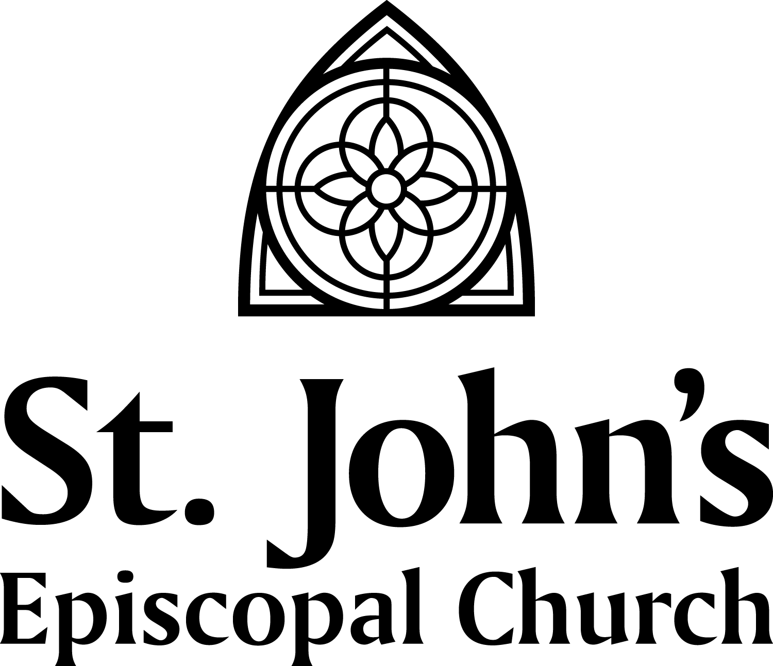

211 North Monroe Street Tallahassee, FL 32301
(850) 222-2636 | www.saint-john.org

